**Setup**

Create directory */home/hdoop/cs523/log*

Create directory */home/hdoop/cs523/conf*

Put *HWFlumeConf.conf* file to */home/hdoop/cs523/flume/conf* directory.

In installed Flume director, Run command:

Shell> bin/flume-ng agent -n agenthw -c /home/hdoop/cs523/flume/conf -f /home/hdoop/cs523/flume/conf/HWFlumeConf.conf

**Testing Steps**

Original HDFS */user/hdoop* directory:

Create 2 files: *log1.txt, log2.txt*

Copy *log1.txt* to */home/hdoop/cs523/log*

Spooldir source will mark *log1.txt* to *log1.txt.COMPLETED*



Observe the console, will see loggerSink prints out content of *log1.txt*

HDFS sink imported successful the content of *log1.txt* to HDFS:

Then, copy *log2.txt* to */home/cs523/log*

Spooldir source will mark *log2.txt* to *log2.txt.COMPLETED*

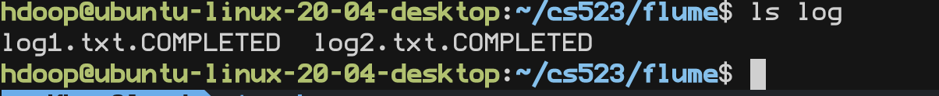

Observe the console, will see loggerSink prints out content of *log2.txt*

HDFS sink imported successful the content of log2.txt to HDFS:

